Ideation Phase

**Empathize & Discover**

|  |  |
| --- | --- |
| Date | 27 June 2025 |
| Team ID | LTVIP2025TMID35316 |
| Project Name | Clean Teach: Transforming Waste Management with Transfer Learning |
| Maximum Marks | 4 Marks |

## 🧭 ****Empathy Map Canvas****

### 👤 ****Target User Persona:****

* **Primary Users:** Municipal workers, recycling center staff, smart city officials
* **Secondary Users:** Industrial waste managers, citizens interacting with public smart bins

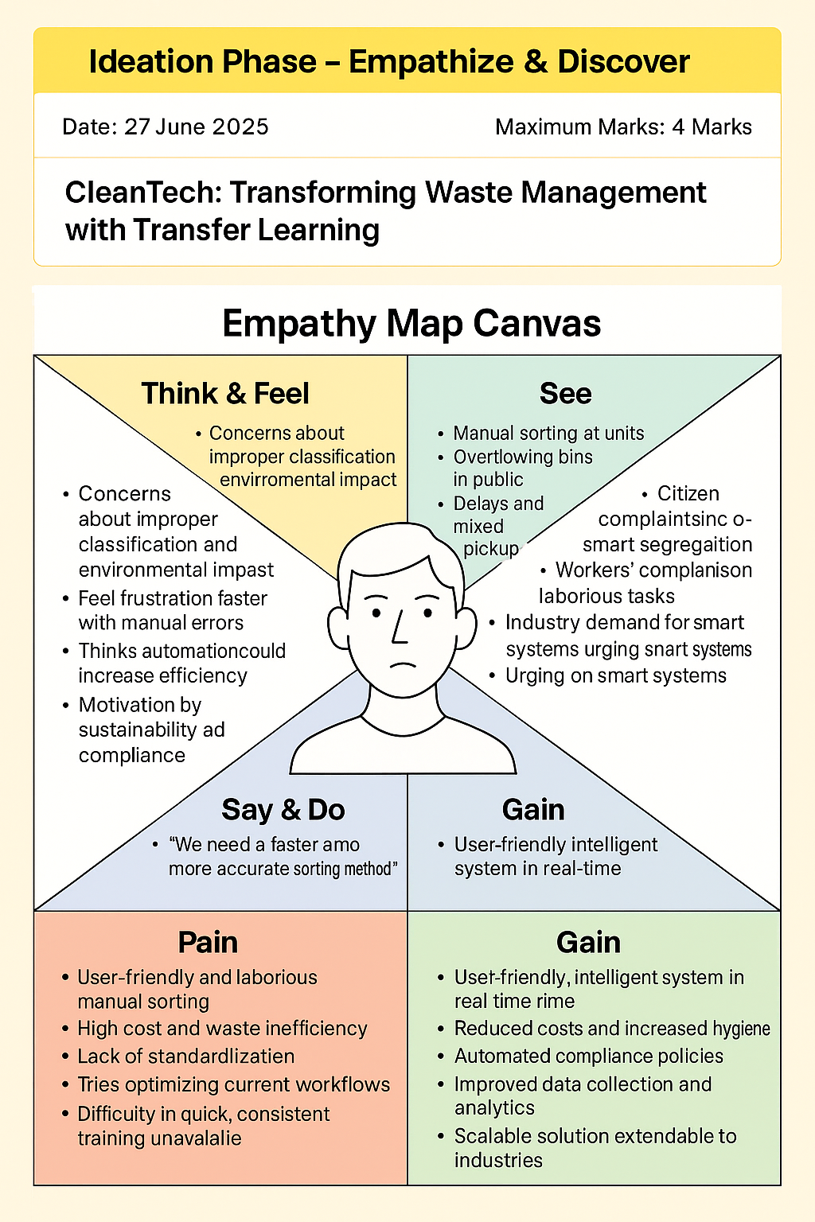

### 🧠 Think & Feel

* **Concerns** about improper waste classification and its environmental impact
* **Wants** a simpler and faster way to sort and dispose of waste
* **Feels frustrated** with inconsistent sorting systems and manual errors
* **Thinks** automation could reduce labor effort and increase efficiency
* **Motivated by** sustainability, compliance, and operational excellence

### 👀 See

* Manual waste sorting at local recycling units
* Overflowing bins with mixed waste in public places
* Delays in waste disposal and non-segregated waste pickup
* Lack of real-time data for efficient waste tracking
* Reports about AI solutions in other smart cities

### 👂 Hear

* Feedback from citizens about lack of smart segregation
* Complaints from waste workers about unhygienic and labor-intensive tasks
* Industry demand for better waste compliance methods
* Environmental agencies urging the adoption of smart waste systems
* Media discussions about AI-based environmental innovation

### 🗣️ Say & Do

* "We need a faster and more accurate sorting method."
* "Manual labor is not sustainable in the long term."
* Encourages tech adoption but is cautious about implementation complexity
* Tries to optimize current manual workflows
* Participates in government or municipal discussions about smart waste solutions

### ❌ Pain

* Manual sorting is slow, laborious, and often inaccurate
* High cost and inefficiency in processing mixed or contaminated waste
* Lack of standardized waste categorization leads to fines or environmental violations
* Real-time tracking of waste is not available
* Difficult to train staff quickly and consistently

### ✅ Gain

* A user-friendly, intelligent system that classifies waste in real time
* Reduced labor costs and increased hygiene for workers
* Automated compliance with recycling and segregation policies
* Improved data collection and decision-making through analytics
* Scalable solution that can be extended across cities and industries

### 📝 Summary

The **Empathy Map Canvas** helped the team deeply understand the pain points, behaviors, and motivations of waste management stakeholders. These insights directly informed the design of **CleanTech**, an AI-powered solution that minimizes manual effort, maximizes segregation accuracy, and contributes to a more sustainable and intelligent waste management ecosystem.